**1. What are the different margins options and do we adjust the margins of**

**the excel worksheet?**

To specify custom page margins, click Custom Margins and then—in the Top, Bottom, Left, and Right boxes—enter the margin sizes that you want.

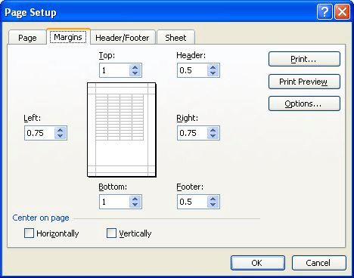

**2. Set a background for your table created.**

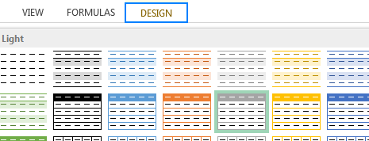

**3. What is freeze panes and why do we use freeze panes? Give**

**examples.**

To keep an area of a worksheet visible while you scroll to another area of the worksheet, go to the View tab, where you can Freeze Panes to lock specific rows and columns in place, or you can Split panes to create separate windows of the same worksheet.

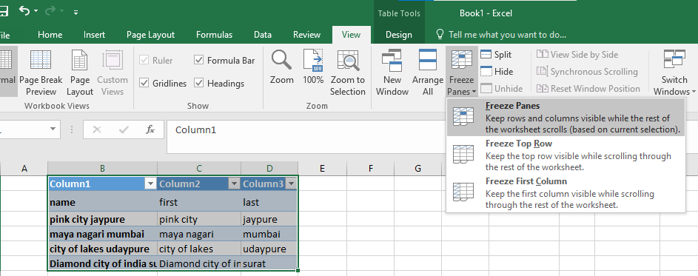

**4. What are the different features available within the Freeze Panes**

**command?**

* Top row freezing
* Some part of sheet freezing in continuous selection
* Freezing first column

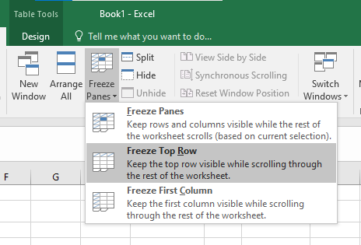

**5. Explain what the different sheet options present in excel are and what**

**they do?**

MS Excel provides various sheet options for printing purpose like generally cell gridlines aren’t printed. If you want your printout to include the gridlines, Choose **Page Layout » Sheet Options group » Gridlines » Check Print**.

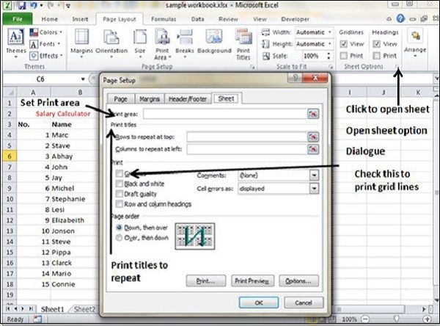

* **Print Area** − You can set the print area with this option.
* **Print Titles** − You can set titles to appear at the top for rows and at the left for columns.
* **Print** −
  + **Gridlines** − Gridlines to appear while printing worksheet.
  + **Black & White** − Select this check box to have your color printer print the chart in black and white.
  + **Draft quality** − Select this check box to print the chart using your printer’s draft-quality setting.
  + **Rows & Column Heading** − Select this check box to have rows and column heading to print.
* **Page Order** −
  + **Down, then Over** − It prints the down pages first and then the right pages.
  + **Over, then Down** − It prints right pages first and then comes to print the down pages.